**Airbnb: Vacation Rentals, Cabins, Houses.**



**Session: 2021**

**Submitted by:**

**Noman Ahmad 2021-SE-24**

**Wali Muhammad 2021-SE-39**

**Supervised by:**

**Ma’am Zahra**

**Sir Zeeshan**

Department of Computer Science, New Campus **University of Engineering and Technology Lahore, Pakistan**

Table of Contents

Abstract 3

Introduction 3

Objective 3

Problem Statement 3

Timeline/Gantt Chart 5

Wireframes 7

Functional Requirements 12

Non-Functional Requirements 13

Group 7 Details 14

Abstract

Our project will connect people who want to rent out their homes with people who are looking for accommodations in specific area. Our Project will be a web portal.

Airbnb increases supply of short-term travel accommodations and slightly lower prices.

The Objective of our project is to offer people an easy, relatively stress-free way to earn some income from their property and to provide guests feel like they are in home rather in a hotel.

As traveling is a part of life. Our project will be very beneficial in future also.

## Introduction

Airbnb is an online marketplace and hospitality service, aiding users to rent or lease accommodation not limited to bed and breakfasts, hostels, homestays, apartments, rooms or hotels for short period of time.[1]

This website is easy to use that a lay man can use it to book residential areas. The website allows its clients to book hotels, apartments, flats, rooms for any number of guests, for a short duration of time. The user can also register as a “Host” to rent their houses and rooms for other people using Airbnb.

Lahore is known as one of Pakistan’s most populated city, and it has a lot of Airbnb’s hotels, apartments and flats to serve the user’s any time. With Airbnb, the Lahore housing market is transferred to short-term rentals. Airbnb is trying to make its service more fast and more efficient.

## Objective

Airbnb’s objective is to**create a world where anyone can belong anywhere** and we are focused on creating an end-to-end travel platform that will handle every part of your trip. As we work to achieve this goal, we are focused on building for the future, driving strong sustained growth, and creating new businesses that will power long-term success.[2]

## Problem Statement

* Time Issue

This application will save a lot of time of user. The user doesn’t need to go for booking. He/she need an active internet connection to use the application and book the hotel at his/her desire location.

* Expensive Hotels

As the Elite class hotels require more money, Airbnb provide users good and first-class hotels and apartment at discount rate. Airbnb has connection over many hotels and it also provides some discount packages for user in First class and Ordinary hotels.

* More Subscription

In other countries the tourist cannot own more than 1 hotel but Airbnb provides its user more than 3 subscriptions at a time. The user can own there at same place or different places. No more than 3 residential places are allowed.

* Get rid of long Queue

Usually, people go physically to book a hotel. In popular hotel, the people face a long queue and they have to wait a long time to request for a room. This application has resolved this issue. The user can book the hotel by one click and get rid of long queue.

* First Check then Book

The people who do not want to visit ever hotel before booking can use Airbnb. This application provides user to take a look at the hotel and check the reviews before booking the hotel. So, he\she can book the hotel according to his/her taste.

* Little experience of Booking

The application is specially made for people which have no idea of hotel booking. This application resolves a big issue of hotel booking as some people do not know how hotels works. The app is very easy to use that a lay man can also use this

|  |
| --- |
| ***“Create a world where anyone can belong anywhere”*** |

**Tools and Technology**

The major tool used in this Project are software based. The whole website is made on HTML, CSS and Bootstrap.

* **HTML and CSS**

HTML is used to create the basic structure of website. CSS is used to add Styling in the website.

* **Bootstrap**

Bootstrap is a free and open-source CSS framework directed at responsive web development. It contains HTML, CSS and JavaScript-based design templates for typography, forms, buttons, navigation, and other interface components.

**Related Work**

This project is similar to the [outdoorsy](http://www.outdoorsy.com) , that provide the facility to accommodate recreational vehicles (campervans, coaches etc.). The introduction to Outdoorsy is, Outdoorsy is a marketplace platform that connects RV owners with other campers. Outdoorsy is an online platform where motorhome owners and renters come together in one place. Owners can rent out their trailers when they’re not using them.[3]

## Timeline/Gantt Chart

In first week, we will work on Requirements. In second week, we will work on HTML and third week we will work on CSS. In the fourth week we will work on Bootstrap.

|  |  |  |  |  |
| --- | --- | --- | --- | --- |
| Project | Week 1-2 | Week 3-5 | Week 5-6 | Week 6-7 |
| Requirements |  |  |  |  |
| HTML & CSS |  |  |  |  |
| Bootstrap |  |  |  |  |
| Testing |  |  |  |  |
| Documentation |  |  |  |  |

## Wireframes

* **Home Page**

T2

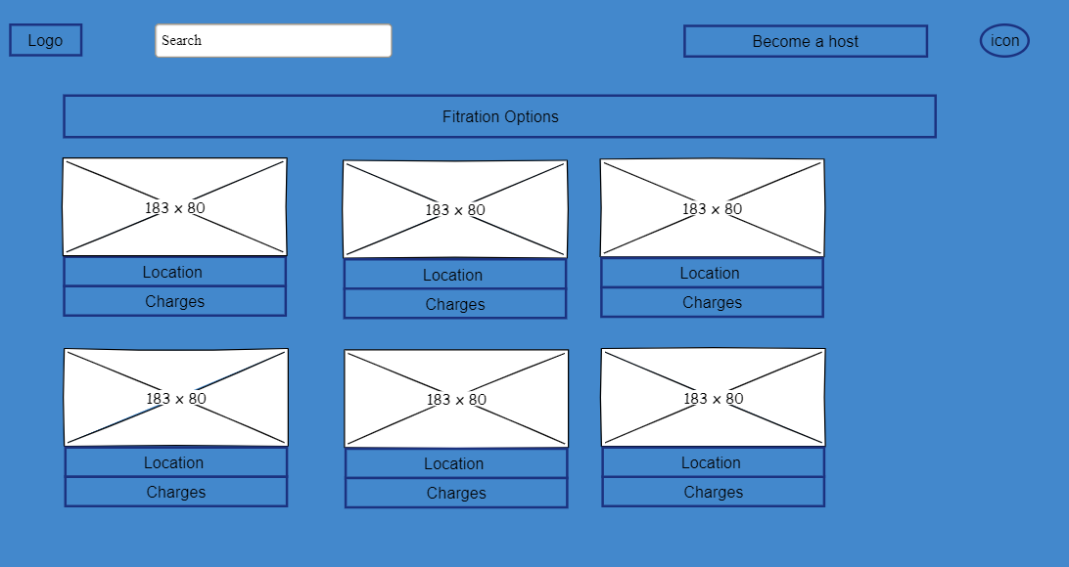

T5

T4

T3

T1

|  |  |
| --- | --- |
| User | Admin |
| **T1:** As a user, I shall be able to search for any location. | **T1:** As an admin I shall manage the search results. |
| **T2:** As a user, I shall be able to become a host for renting out residential places. | **T2:** As an admin, I shall allow the user to become a host for renting out residential places. |
| **T3:** As a user, I shall be able to login or sign up my account. | **T3:** As an admin, I shall manage the login details of the users. |
| **T4:** As a user, I shall be able to apply filter according to my requirements. | **T4:** As an admin, I shall manage the results according to filter. |
| **T5:** As a user, I shall be able to view the listing of recommended residential places. | **T5:** As an admin, I shall display the most visited residential places to the user. |

* **Login or sign in Modal**

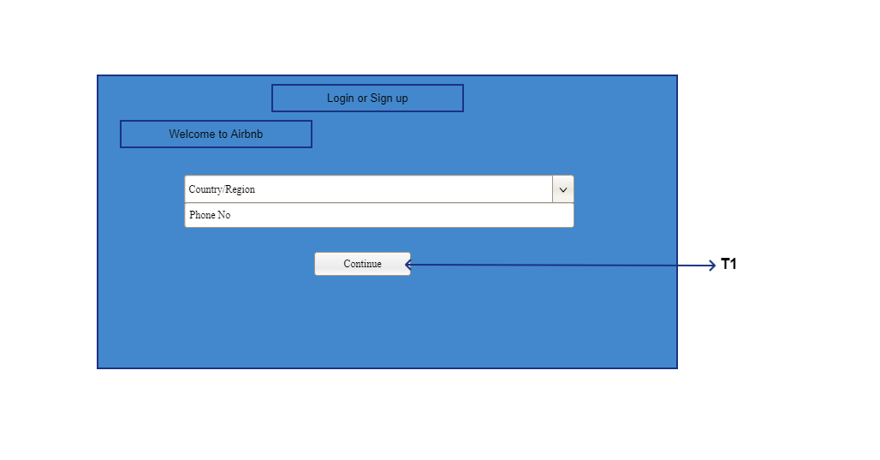

|  |  |
| --- | --- |
| User | Admin |
| **T1**: As a user, I shall be able to login to my account. | **T1:** As an admin, I shall manage login details. |

* **Sign up Modal**

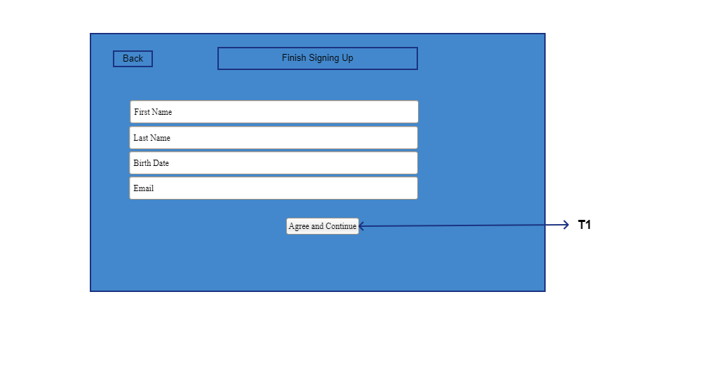

|  |  |
| --- | --- |
| User | Admin |
| **T1**: As a user, I shall be able to create a new account. | **T1**: As an admin, I shall store the account details. |

* **Hosting Page**

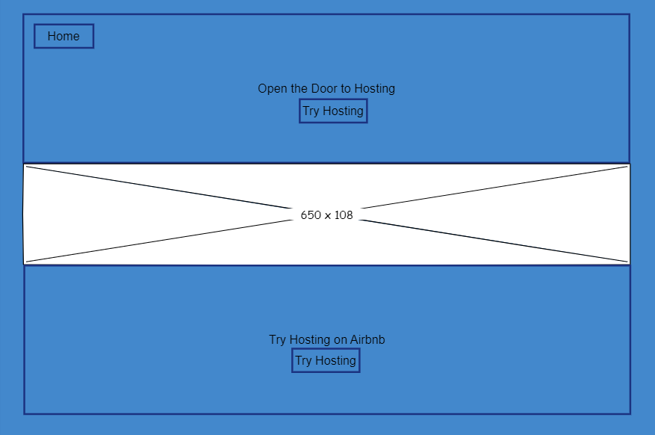

T2

T1

|  |  |
| --- | --- |
| User | Admin |
| **T1**: As a user, I shall be able return to home page. | **T1**: As an admin, I shall allow the user return to home page. |
| **T2:** As a user, I shall be able to become a host for renting out residential places. | **T2:** As an admin, I shall allow the user to become a host for renting out residential places. |

* **Search Page**

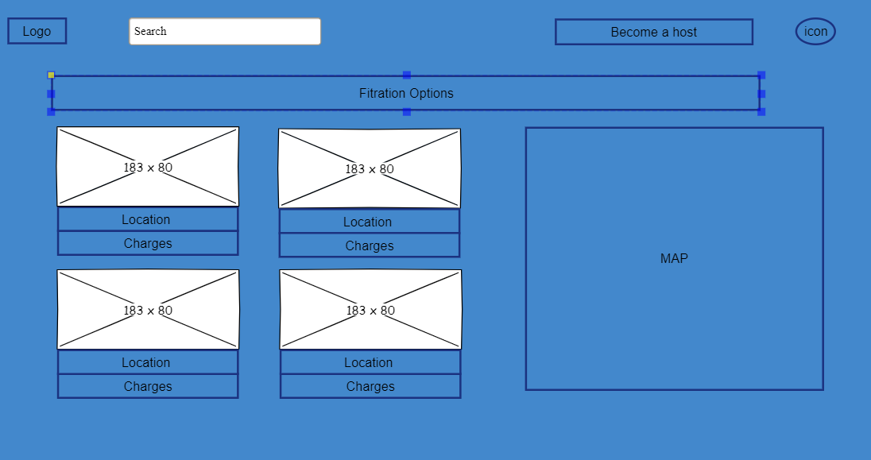

T3

T5

T2

T4

T1

|  |  |
| --- | --- |
| User | Admin |
| **T1:** As a user, I shall be able to search for any other location. | **T1:** As an admin I shall manage the search results. |
| **T2:** As a user, I shall be able to become a host for renting out residential places. | **T2:** As an admin, I shall allow the user to become a host for renting out residential places. |
| **T3:** As a user, I shall be able to login or sign up my account. | **T3:** As an admin, I shall manage the login details of the users. |
| **T4:** As a user, I shall be able to apply filter according to my requirements. | **T4:** As an admin, I shall manage the results according to filter. |
| **T5:** As a user, I shall be able to view the search results. | **T5:** As an admin I shall display the search results. |

* **Product Page**

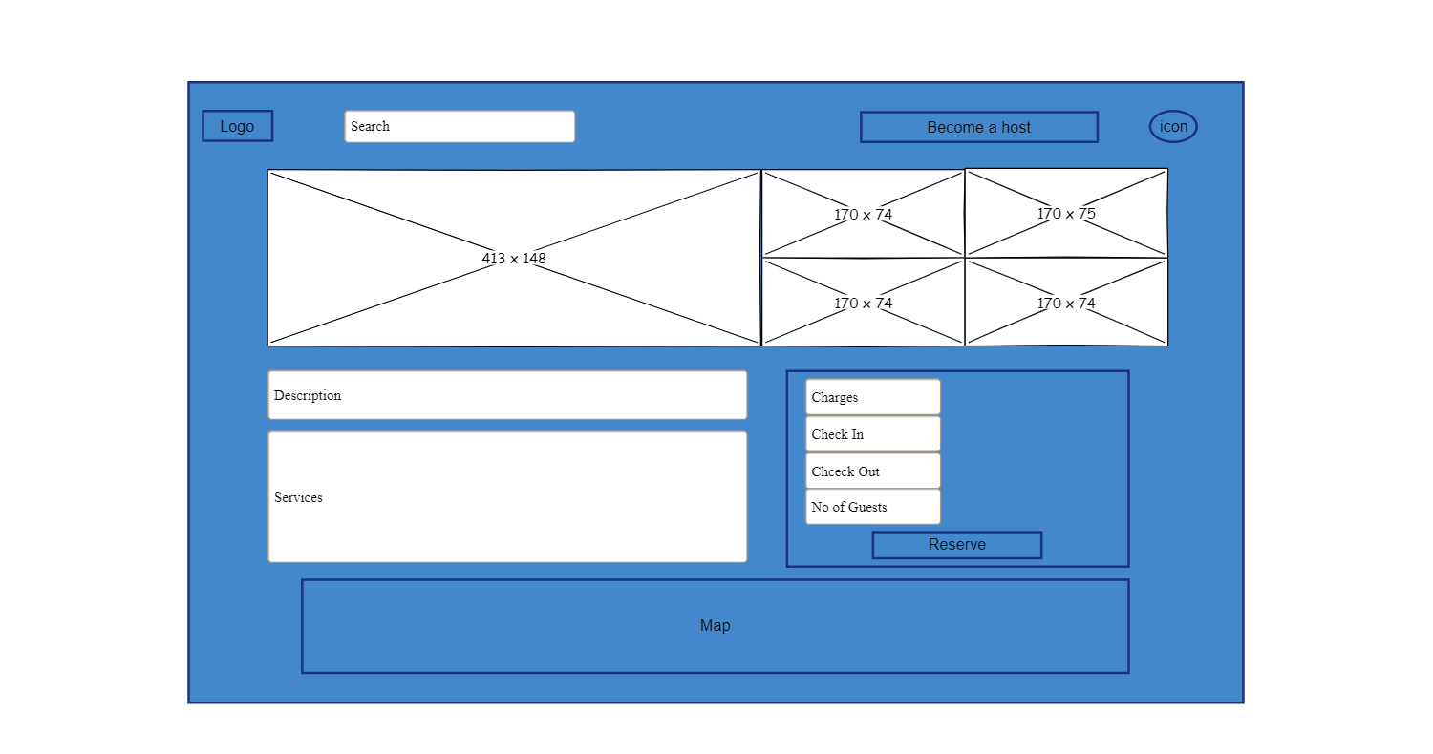

T4

T3

T2

T1

|  |  |
| --- | --- |
| User | Admin |
| **T1:** As a user, I shall be able to search for any other location. | **T1:** As an admin I shall manage the search results. |
| **T2:** As a user, I shall be able to become a host for renting out residential places. | **T2:** As an admin, I shall allow the user to become a host for renting out residential places. |
| **T3:** As a user, I shall be able to login or sign up my account. | **T3:** As an admin, I shall manage the login details of the users. |
| **T4:** As a user, I shall be able to reserve/book the residential area. | **T4:** As an admin, I shall check the availability and allow the user to book the residential area. |

* **Payment Page**

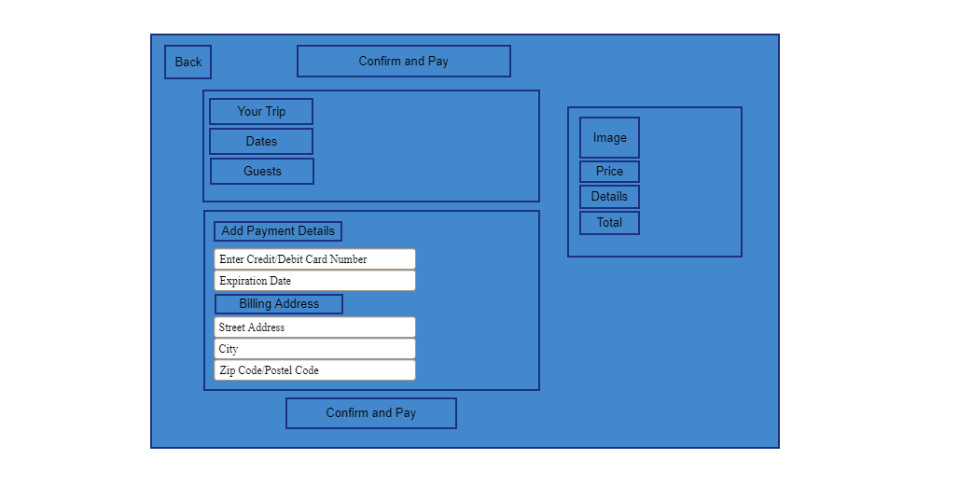

T1

|  |  |
| --- | --- |
| User | Admin |
| **T1:** As a user, I shall be able to add payment method and pay for reservation. | **T1:** As an admin, I shall verify the payment method and reserve the hotel for the user. |

* **Confirmation Page**

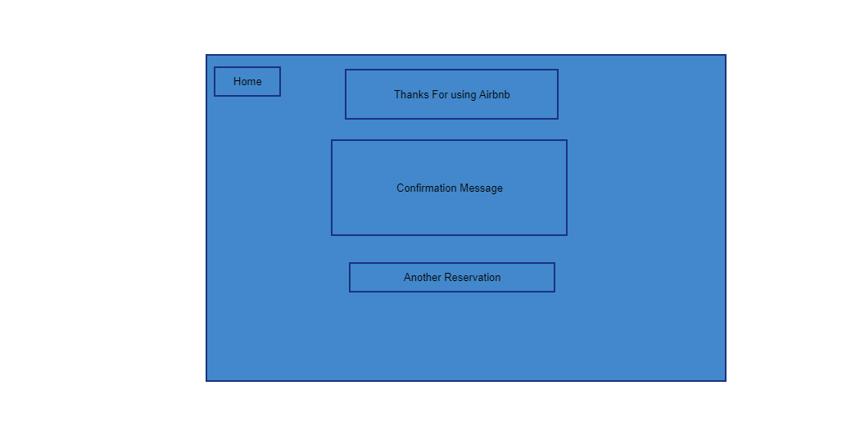

T11

|  |  |
| --- | --- |
| User | Admin |
| **T1:** As a user, I shall be able to reserve another booking. | **T1:** As an admin, I shall allow user to reserve another booking. |

# Functional and Non-Functional Requirements

## Functional Requirements

* The tourist shall be able to search for a particular location.
* The tourist shall be able to view all the homes, flats available for the particular area.
* The tourist shall be able to view all the facilities available at the particular home / flat.
* The tourists shall be able to book flat after signing in their account.
* The tourists shall be able to see all their previous bookings.

|  |  |  |
| --- | --- | --- |
| Employee Badge | Gears | Handshake |

* The tourists shall be able to review their experience when they checkout.
* The tourist shall be able to make payment of the booking of home / flat.
* The tourist shall be able to view all the pictures of the flat.
* The tourist shall be able to book the flat for more than 1 day.
* The co-host shall be to view all his listings.
* The co-host shall be able to mark his listing as unavailable, in case the flat is booked.
* The co-host shall be able to manage (add, edit or delete) his listings.
* The co-host shall be able to receive his payments online.
* The co-host shall be able to see all previous and future bookings of his flat.

## Non-Functional Requirements

|  |  |
| --- | --- |
| * Performance Requirement * The response time for booking a flat must be from 1 to 5 seconds. * The project must provide a throughput of 50 requests at a time. * The project must be able to view 10 listings on 1 page. * Scalability Requirements * The system must able to handle listings of up to 25 cities. * Capacity Requirements: * The system must be able to handle 500 users at a time. * The system must be able to handle listing of 10 cities. * It must respond 1000 users at a time. * Availability Requirements * The service must be provided 24/7. * The system must be available at 365 Days in a Year. * In case of any mishap or emergency users must be notified at least 1 day before the unavailability of service. * Maintainability Requirements * The system must be easy to understand so that it can be easily repaired or improved. * Security Requirements * The system should be secure. It should provide security against ethical hacking. * Every check-in and check-out detail of last 30 days must be stored. * The information of every user and co-host must be stored. * Regularity Requirements * The system must follow the rules and regulations of the government. * It must not share the personal data of its user with someone else. * Manageability Requirements * The system must be easily manageable. It should be easy to add or remove any data in the system. * Data Integrity Requirements * If any transaction is made, it must be updated in the database. * Useability Requirements * The system must be easy to understand, the user with color blindness must be able to easily view and understand the system. * Interoperability Requirements * The system must be self-explained, i.e., when we hover over any button, it must explain its purpose. |  |
| * Performance Requirement * The response time for booking a flat must be from 1 to 5 seconds. * The project must provide a throughput of 50 requests at a time. * The project must be able to view 10 listings on 1 page. * Scalability Requirements * The system must able to handle listings of up to 25 cities. * Capacity Requirements: * The system must be able to handle 500 users at a time. * The system must be able to handle listing of 10 cities. * It must respond 1000 users at a time. * Availability Requirements * The service must be provided 24/7. * The system must be available at 365 Days in a Year. * In case of any mishap or emergency users must be notified at least 1 day before the unavailability of service. * Maintainability Requirements * The system must be easy to understand so that it can be easily repaired or improved. * Security Requirements * The system should be secure. It should provide security against ethical hacking. * Every check-in and check-out detail of last 30 days must be stored. * The information of every user and co-host must be stored. * Regularity Requirements * The system must follow the rules and regulations of the government. * It must not share the personal data of its user with someone else. * Manageability Requirements * The system must be easily manageable. It should be easy to add or remove any data in the system. * Data Integrity Requirements * If any transaction is made, it must be updated in the database. * Useability Requirements * The system must be easy to understand, the user with color blindness must be able to easily view and understand the system. * Interoperability Requirements * The system must be self-explained, i.e., when we hover over any button, it must explain its purpose.  Test Cases  |  |  |  |  | | --- | --- | --- | --- | | TEST CASE ID | TEST CASE DATE | TEST CASE DISCRIPTION | EXPECTED RESULTS | | AB_001 | 20/06/2022 | Test the login functionality of airbnb.com | Pass/fail/not executed | |  |

|  |  |  |  |  |
| --- | --- | --- | --- | --- |
| Step # | Step Details | Expected Results | Actual Results | Pass / Fail Not/executed / Suspend |
| 1 | Navigate to www.airbnb.com | Site should open | As expected | pass |
| 2 | Enter username | Wrong username should rejected | As expected | pass |
| 3 | Enter password | Wrong password should rejected | As expected | pass |
| 4 | Username and password both correct | Login successful | As expected | pass |

|  |  |  |  |
| --- | --- | --- | --- |
| TEST CASE ID | TEST CASE DATE | TEST CASE DISCRIPTION | EXPECTED RESULTS |
| AB_002 | 20/06/2022 | Test the hotel booking functionality of Airbnb.com | Pass/fail/not executed |

Test scenario: check valid input on entering a number of inputs

|  |  |  |  |  |
| --- | --- | --- | --- | --- |
| Step # | Step Details | Expected Results | Actual Results | Pass / Fail Not/executed / Suspend |
| 1 | Select Hotel | Should Display the Description page of Hotel. | As expected | pass |
| 2 | Select Check-In and Check out Dates | Should Display the total bill According to no of days. | As expected | pass |
| 3 | Enter no of Guests less than zero | Should be rejected | As expected | pass |
| 4 | Enter correct no of Guests | Should be accepted | As expected | pass |
| 5 | Click on Reserve Button (without Login) | Should ask to login first | As expected | pass |
| 6 | Click on Reserve Button (After Login) | Should open Payment Page | As expected | pass |

|  |  |  |  |
| --- | --- | --- | --- |
| TEST CASE ID | TEST CASE DATE | TEST CASE DISCRIPTION | EXPECTED RESULTS |
| AB_003 | 20/06/2022 | Test the hotel Payment functionality of Airbnb.com | Pass/fail/not executed |

Test scenario: check valid input on entering a number of inputs

|  |  |  |  |  |
| --- | --- | --- | --- | --- |
| Step # | Step Details | Expected Results | Actual Results | Pass / Fail Not/executed / Suspend |
| 1 | Enter Invalid Format of Credit Card | Should not accept the input. | As expected | pass |
| 2 | Enter Valid Format of Credit Card | Should accept the input. | As expected | pass |
| 3 | Enter Invalid Expiration Date | Should not confirm transaction. | As expected | pass |
| 4 | Enter Valid Expiration Date | Should confirm the transaction. | As expected | pass |
| 5 | Enter the valid address, city and postal code. | Should accept the input. | As expected | pass |
| 6 | Enter the invalid address, city and postal code. | Should not accept the input. | As expected | pass |
| 7 | Click on Confirm Payment Button without filling form | Should not confirm transaction. | As expected | pass |
| 8 | Click on Confirm Payment Button | Booking should be confirm. | As expected | pass |

|  |  |  |  |
| --- | --- | --- | --- |
| TEST CASE ID | TEST CASE DATE | TEST CASE DISCRIPTION | EXPECTED RESULTS |
| AB_004 | 20/06/2022 | Test the hotel Payment functionality of Airbnb.com | Pass/fail/not executed |

Test scenario: check valid input on entering a number of inputs

|  |  |  |  |  |
| --- | --- | --- | --- | --- |
| Step # | Step Details | Expected Results | Actual Results | Pass / Fail Not/executed / Suspend |
| 1 | Enter Invalid Format of Credit Card | Should not accept the input. | As expected | pass |
| 2 | Enter Valid Format of Credit Card | Should accept the input. | As expected | pass |
| 3 | Enter Invalid Expiration Date | Should not confirm transaction. | As expected | pass |
| 4 | Enter Valid Expiration Date | Should confirm the transaction. | As expected | pass |
| 5 | Enter the valid address, city and postal code. | Should accept the input. | As expected | pass |
| 6 | Enter the invalid address, city and postal code. | Should not accept the input. | As expected | pass |
| 7 | Click on Confirm Payment Button without filling form | Should not confirm transaction. | As expected | pass |
| 8 | Click on Confirm Payment Button | Booking should be confirm. | As expected | pass |

## Group 7 Details

**Group Member’s**

* Noman Ahmad (2021-SE-24).
* Wali Muhammad (2021-SE-39).

Both worked together on HTML, CSS, Bootstrap and Proposal.

**The End**

1. [How Airbnb Works (investopedia.com)](https://www.investopedia.com/articles/personal-finance/032814/pros-and-cons-using-airbnb.asp#:~:text=Airbnb%20is%20an%20online%20marketplace%20that%20connects%20people,on%20an%20air%20mattress%20in%20their%20living%20room.)
2. <https://news.airbnb.com/airbnb-2019-business-update/>
3. [Outdoorsy Review 2022 - Looking at The Fees, Insurance, Rentals & More (thervnomad.com)](https://thervnomad.com/outdoorsy-review/)